Bipyramid

Definition
# Source: AI Source: Provided by: [Data Path: Persons Table -> ID Column: 1, Name_En Column: Motasem Essam] -> From: [ChatGPT] on [7/25/2026]
A Bipyramid is a convex polyhedron formed by joining two pyramids along a common polygonal base, with the two pyramids extending in opposite directions from that base.
The shared polygonal base becomes an internal face and is not part of the external surface. The resulting solid has two opposite apexes connected to the vertices of the common base.
A bipyramid is classified according to the shape of its polygonal base.

Simple Definition
# Source: AI Source: Provided by: [Data Path: Persons Table -> ID Column: 1, Name_En Column: Motasem Essam] -> From: [ChatGPT] on [7/25/2026]
A bipyramid is a three-dimensional solid formed by joining two pyramids base-to-base, creating two opposite apexes and triangular faces surrounding a central polygonal region.
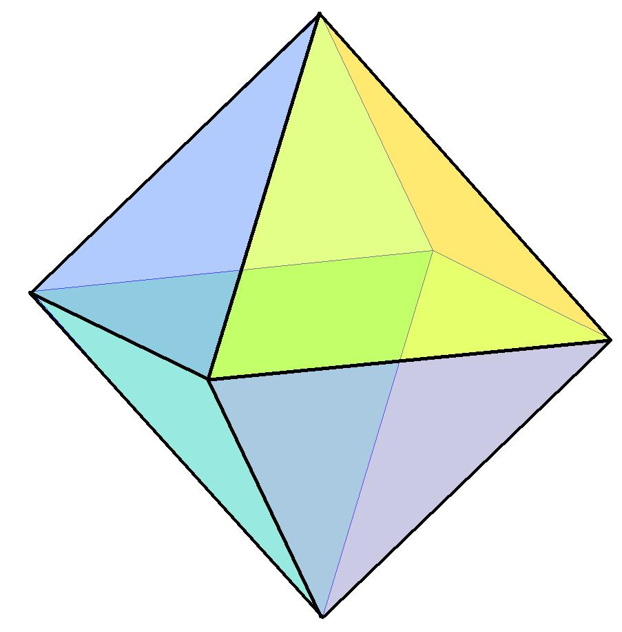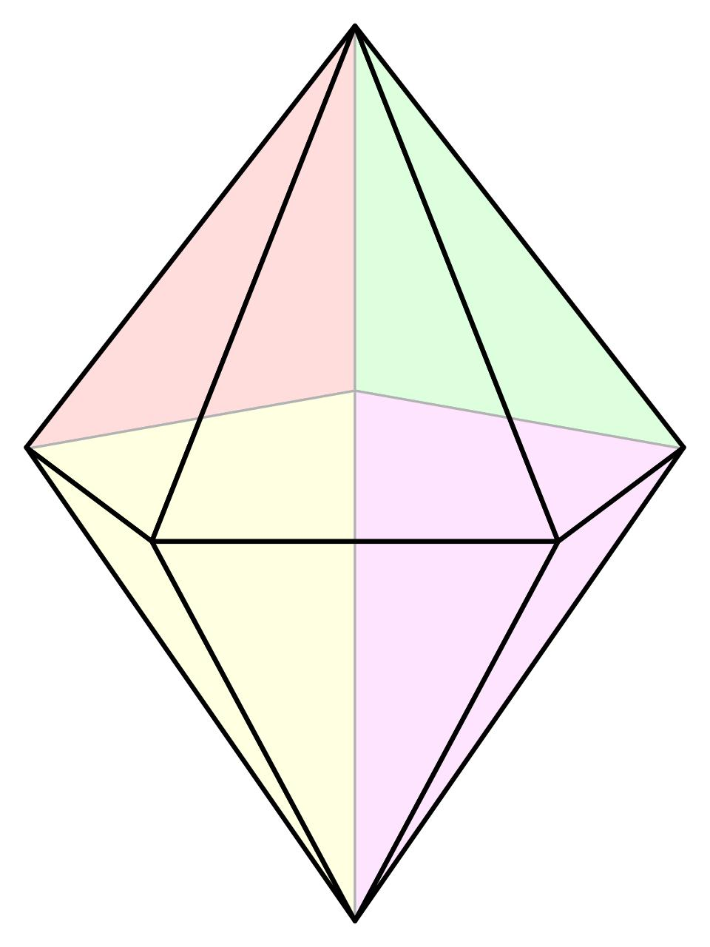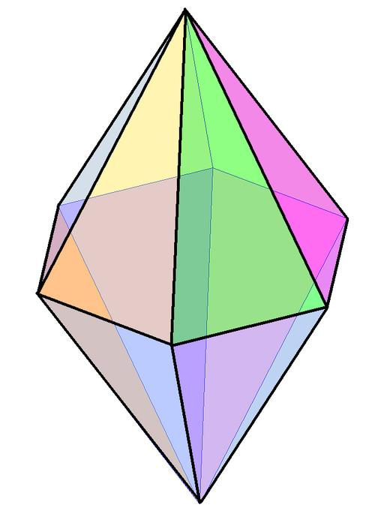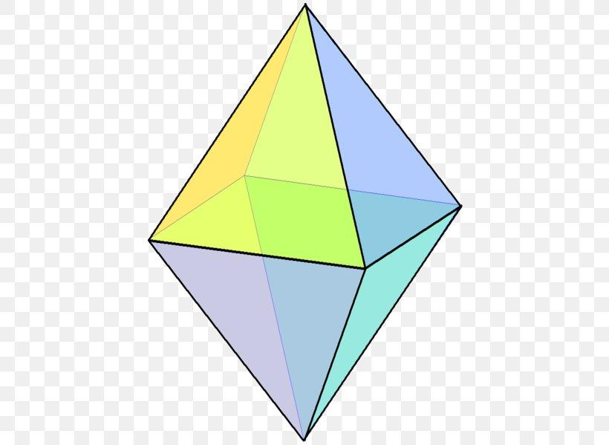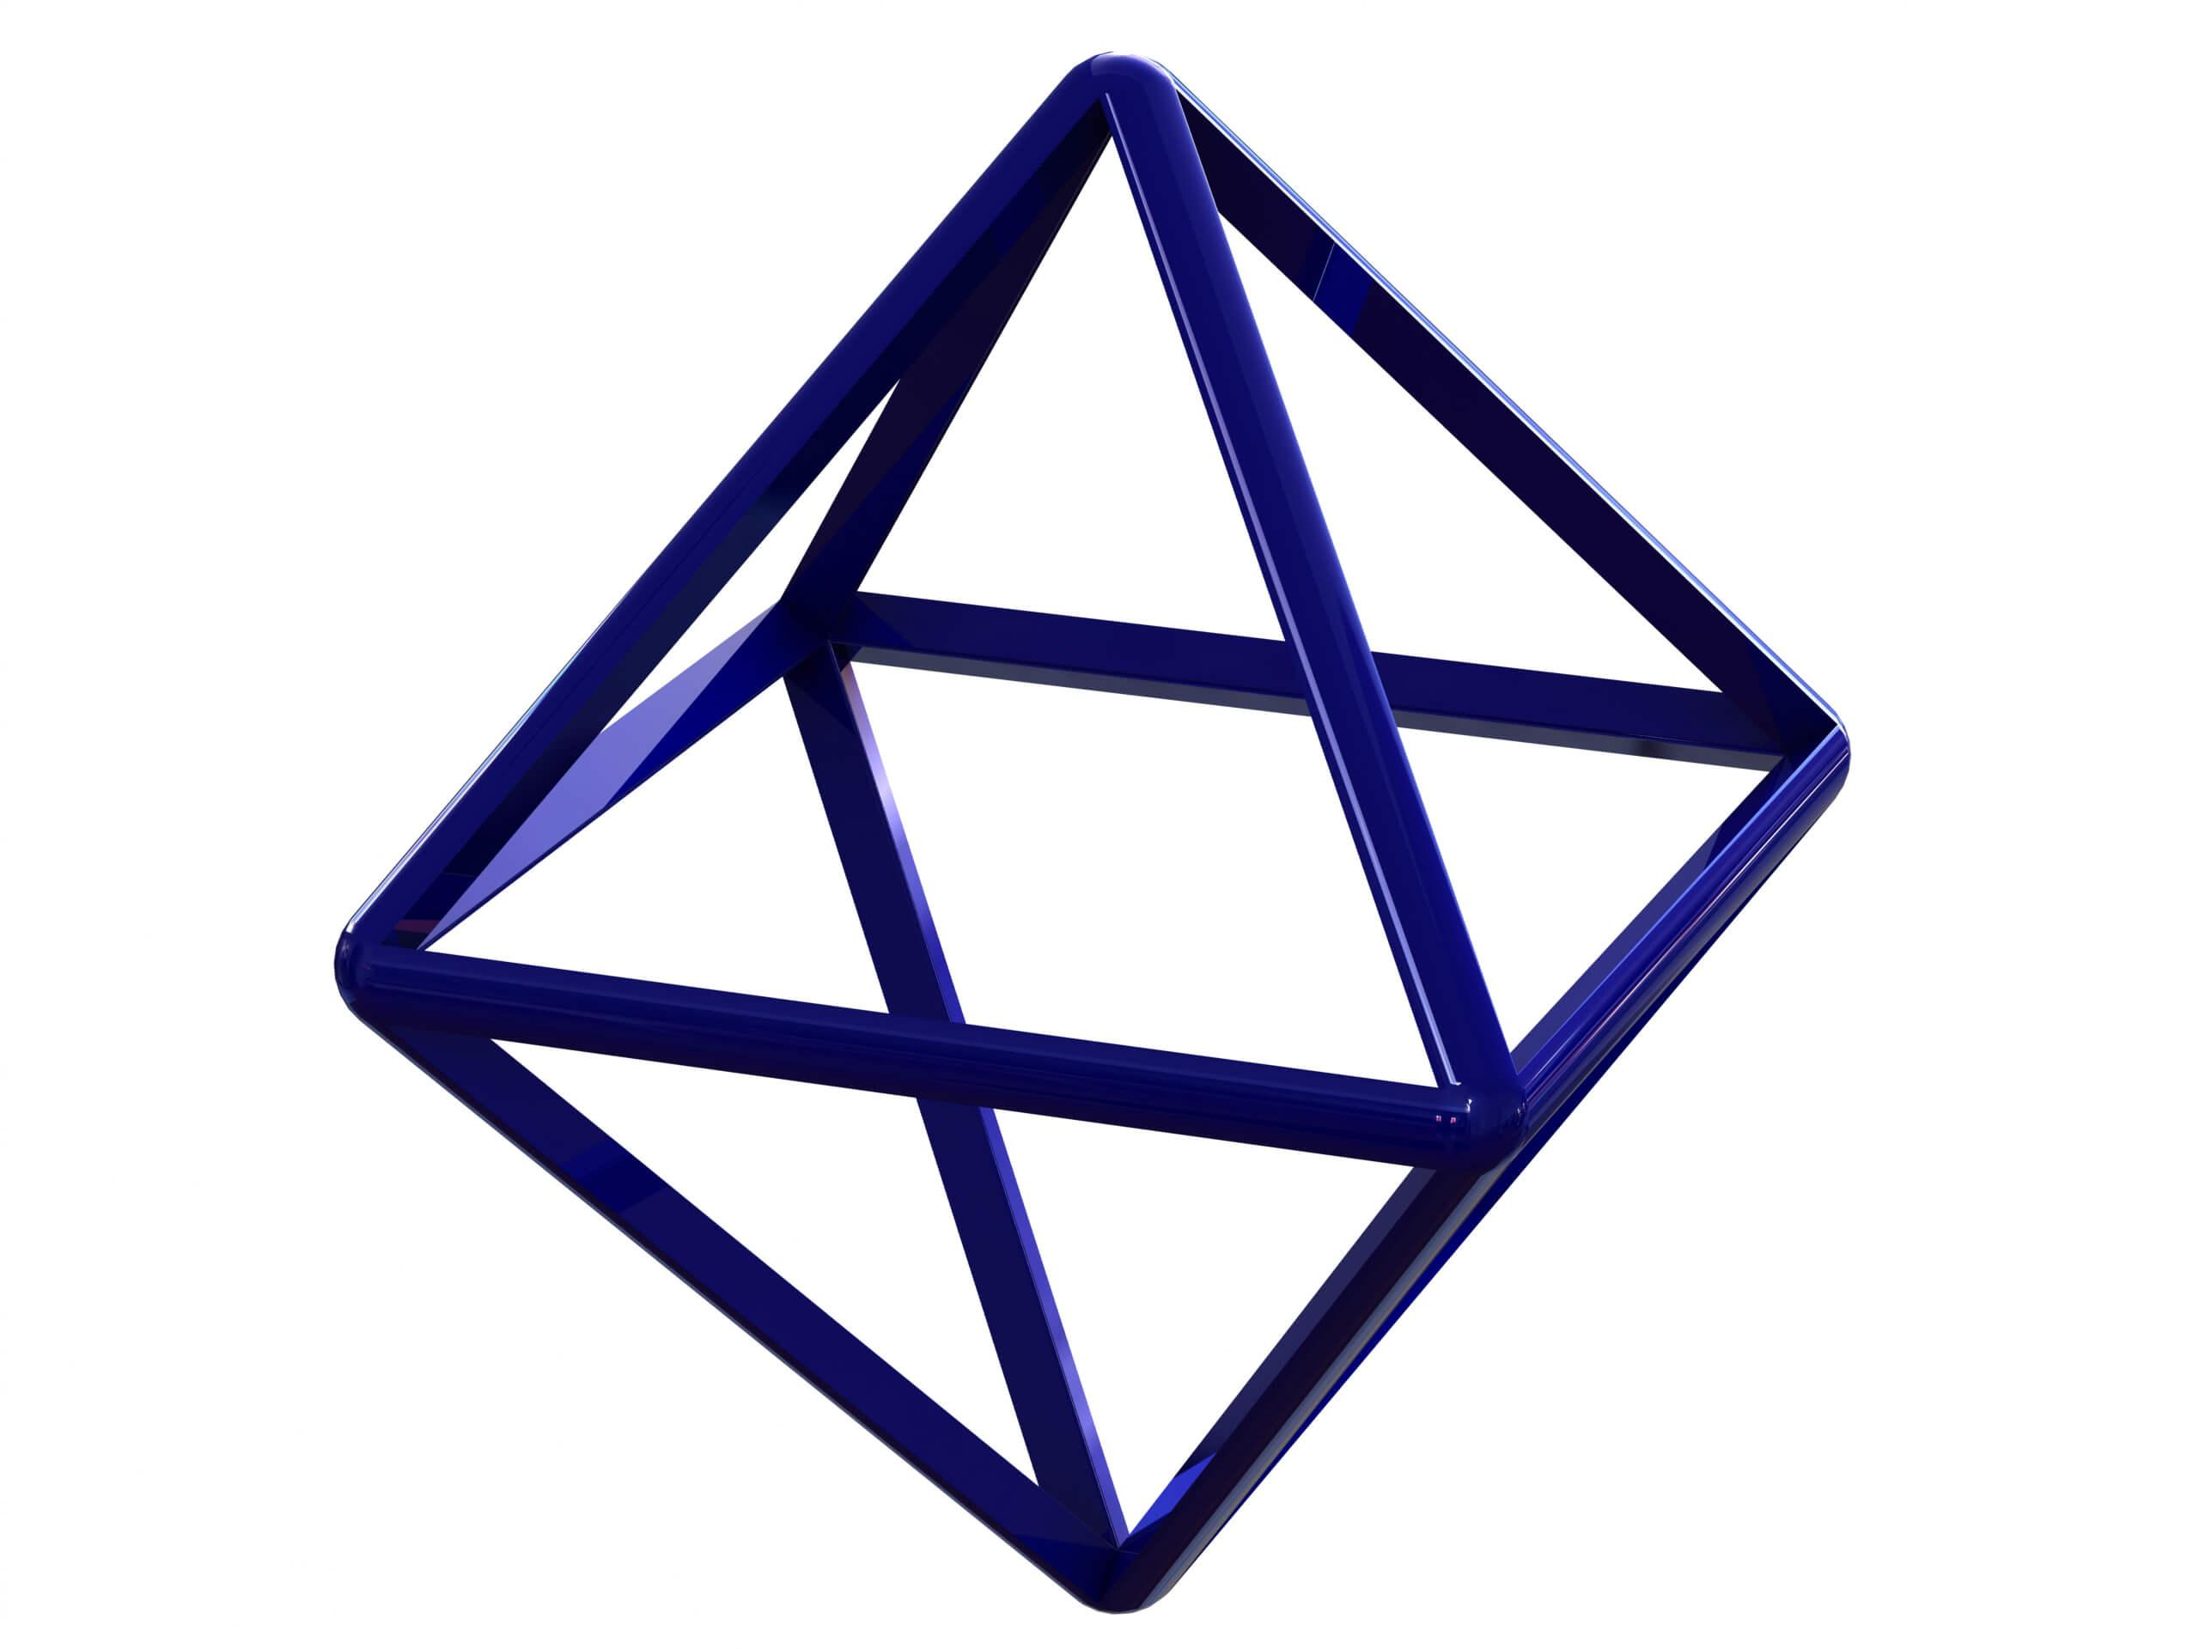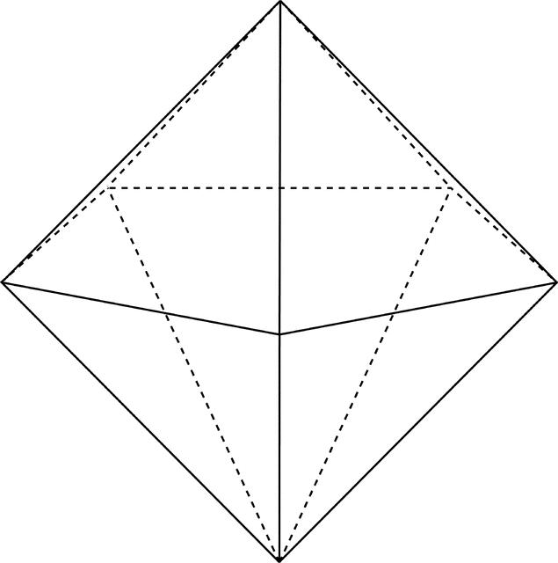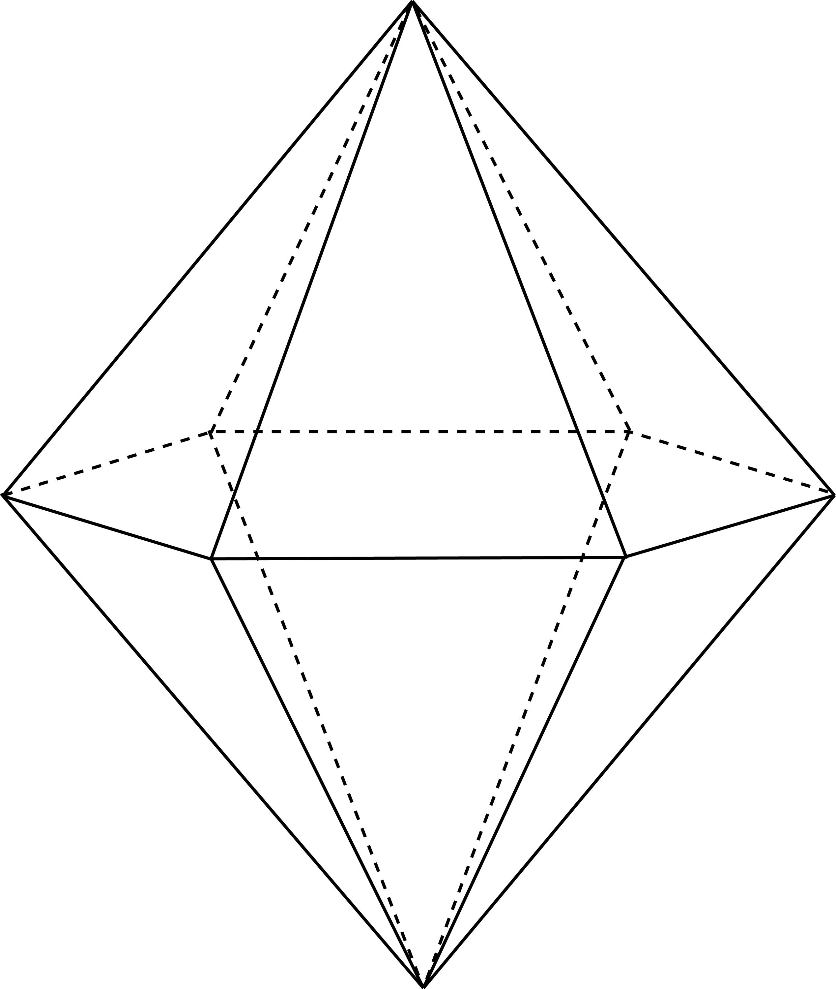

Geometric Structure
# Source: AI Source: Provided by: [Data Path: Persons Table -> ID Column: 1, Name_En Column: Motasem Essam] -> From: [ChatGPT] on [7/25/2026]
A bipyramid consists of the following elements:
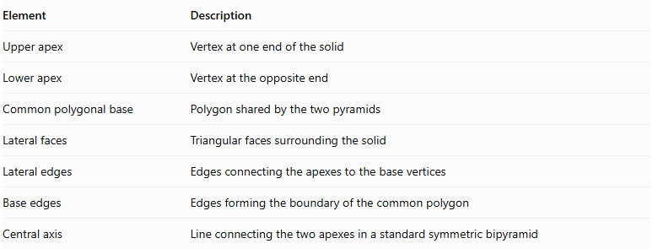
Element | Description
Upper apex | Vertex at one end of the solid
Lower apex | Vertex at the opposite end
Common polygonal base | Polygon shared by the two pyramids
Lateral faces | Triangular faces surrounding the solid
Lateral edges | Edges connecting the apexes to the base vertices
Base edges | Edges forming the boundary of the common polygon
Central axis | Line connecting the two apexes in a standard symmetric bipyramid
Important: The common polygonal base is an internal construction element. It is not an external face of the finished bipyramid.

Main Classification
# Source: AI Source: Provided by: [Data Path: Persons Table -> ID Column: 1, Name_En Column: Motasem Essam] -> From: [ChatGPT] on [7/25/2026]
Bipyramids are classified according to the number of sides of their common polygonal base.
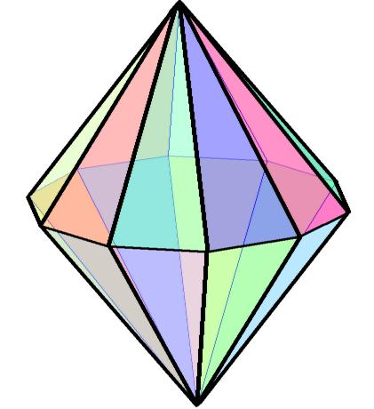
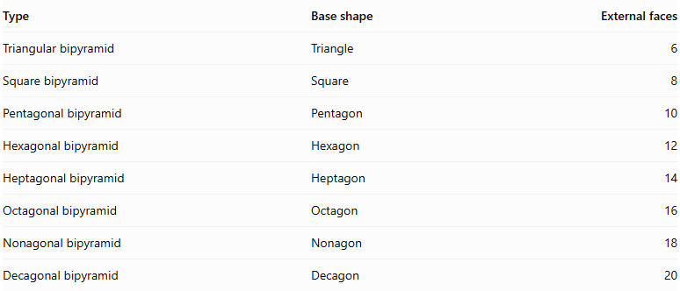
Type | Base shape | External faces
Triangular bipyramid | Triangle | 6
Square bipyramid | Square | 8
Pentagonal bipyramid | Pentagon | 10
Hexagonal bipyramid | Hexagon | 12
Heptagonal bipyramid | Heptagon | 14
Octagonal bipyramid | Octagon | 16
Nonagonal bipyramid | Nonagon | 18
Decagonal bipyramid | Decagon | 20

Geometric Properties
# Source: AI Source: Provided by: [Data Path: Persons Table -> ID Column: 1, Name_En Column: Motasem Essam] -> From: [ChatGPT] on [7/25/2026]
For an $n$-gonal bipyramid:

A. Faces
# Source: AI Source: Provided by: [Data Path: Persons Table -> ID Column: 1, Name_En Column: Motasem Essam] -> From: [ChatGPT] on [7/25/2026]
Every base edge forms one triangular face with the upper apex and another triangular face with the lower apex.
$$F=2n$$
All external faces are triangles.

B. Edges
# Source: AI Source: Provided by: [Data Path: Persons Table -> ID Column: 1, Name_En Column: Motasem Essam] -> From: [ChatGPT] on [7/25/2026]
The edges consist of:
- $n$ upper lateral edges.
- $n$ lower lateral edges.
- $n$ edges around the common polygonal base.
Therefore:
$$E=3n$$

C. Vertices
# Source: AI Source: Provided by: [Data Path: Persons Table -> ID Column: 1, Name_En Column: Motasem Essam] -> From: [ChatGPT] on [7/25/2026]
The vertices consist of:
- One upper apex.
- One lower apex.
- $n$ vertices around the common polygonal base.
Therefore:
$$V=n+2$$

Mathematical Properties

A. Euler's Formula
# Source: AI Source: Provided by: [Data Path: Persons Table -> ID Column: 1, Name_En Column: Motasem Essam] -> From: [ChatGPT] on [7/25/2026]
For a convex bipyramid:
$$V-E+F=2$$
Substituting the general formulas:
$$(n+2)-3n+2n=2$$

B. Total Number of External Faces
# Source: AI Source: Provided by: [Data Path: Persons Table -> ID Column: 1, Name_En Column: Motasem Essam] -> From: [ChatGPT] on [7/25/2026]
$$F=2n$$

C. Total Number of Edges
# Source: AI Source: Provided by: [Data Path: Persons Table -> ID Column: 1, Name_En Column: Motasem Essam] -> From: [ChatGPT] on [7/25/2026]
$$E=3n$$

D. Total Number of Vertices
# Source: AI Source: Provided by: [Data Path: Persons Table -> ID Column: 1, Name_En Column: Motasem Essam] -> From: [ChatGPT] on [7/25/2026]
$$V=n+2$$

E. Surface Area
# Source: AI Source: Provided by: [Data Path: Persons Table -> ID Column: 1, Name_En Column: Motasem Essam] -> From: [ChatGPT] on [7/25/2026]
For two pyramids with a common base:
$$SA={SA}_{upper}+{SA}_{lower}$$
The internal common base is excluded.

F. Volume
# Source: AI Source: Provided by: [Data Path: Persons Table -> ID Column: 1, Name_En Column: Motasem Essam] -> From: [ChatGPT] on [7/25/2026]
$$V_{solid}=V_{upper}+V_{lower}$$
For a common base with area $B$, and upper and lower heights $h_{1}$ and $h_{2}$:
$$V_{solid}=\frac{1}{3}B(h_{1}+h_{2})$$

Symmetry
# Source: AI Source: Provided by: [Data Path: Persons Table -> ID Column: 1, Name_En Column: Motasem Essam] -> From: [ChatGPT] on [7/25/2026]
A regular bipyramid, formed from two congruent regular pyramids joined along their bases, has:
- An $n$-fold rotational symmetry axis.
- A horizontal reflection plane through the common base.
- Vertical reflection planes containing the central axis, depending on the base polygon's symmetry.
- Central inversion symmetry when the upper and lower apexes are positioned symmetrically.
The exact symmetry depends on the shape of the base and the relative dimensions of the two pyramids.

Relationship to Other Solids
# Source: AI Source: Provided by: [Data Path: Persons Table -> ID Column: 1, Name_En Column: Motasem Essam] -> From: [ChatGPT] on [7/25/2026]
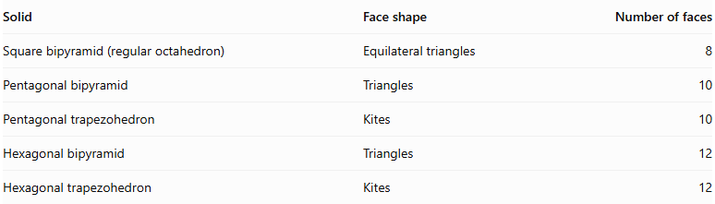
Solid | Face shape | Number of faces
Square bipyramid (regular octahedron) | Equilateral triangles | 8
Pentagonal bipyramid | Triangles | 10
Pentagonal trapezohedron | Kites | 10
Hexagonal bipyramid | Triangles | 12
Hexagonal trapezohedron | Kites | 12
Important distinction:
- A bipyramid has triangular external faces.
- A trapezohedron has kite-shaped quadrilateral external faces.
- Both can have the same numbers of faces, edges, and vertices for the same value of $n$, but their face structures are different.

Worked Examples
# Source: AI Source: Provided by: [Data Path: Persons Table -> ID Column: 1, Name_En Column: Motasem Essam] -> From: [ChatGPT] on [7/25/2026]
Example 1: Calculate the number of faces, edges, and vertices of a pentagonal bipyramid.
Given:
$$n=5$$
Faces:
$$F=2(5)=10$$
Edges:
$$E=3(5)=15$$
Vertices:
$$V=5+2=7$$
Therefore:
$$\boxed{F=10, E=15, V=7}$$
Example 2: Calculate the volume of a bipyramid.
Given:
- Common base area: $B=30{ cm}^{2}$
- Upper pyramid height: $h_{1}=8 cm$
- Lower pyramid height: $h_{2}=6 cm$
$$V=\frac{1}{3}B(h_{1}+h_{2})$$
$$V=\frac{1}{3}(30)(8+6)$$
$$\boxed{V=140{ cm}^{3}}$$

Constructing Bipyramids in Solid Geometry

Geometric Instruments Used
# Source: AI Source: Provided by: [Data Path: Persons Table -> ID Column: 1, Name_En Column: Motasem Essam] -> From: [ChatGPT] on [7/25/2026]
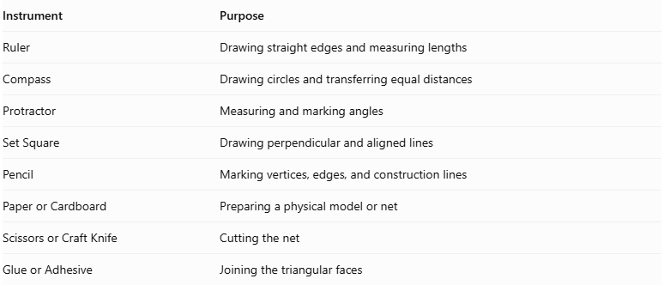
Instrument | Purpose
Ruler | Drawing straight edges and measuring lengths
Compass | Drawing circles and transferring equal distances
Protractor | Measuring and marking angles
Set Square | Drawing perpendicular and aligned lines
Pencil | Marking vertices, edges, and construction lines
Paper or Cardboard | Preparing a physical model or net
Scissors or Craft Knife | Cutting the net
Glue or Adhesive | Joining the triangular faces

Instrument-Based Construction Procedures
# Source: AI Source: Provided by: [Data Path: Persons Table -> ID Column: 1, Name_En Column: Motasem Essam] -> From: [ChatGPT] on [7/25/2026]
A bipyramid can be constructed using geometric instruments by first constructing its shared polygonal base and then connecting its vertices to two apices.

Preparing the Shared Base Polygon
# Source: AI Source: Provided by: [Data Path: Persons Table -> ID Column: 1, Name_En Column: Motasem Essam] -> From: [ChatGPT] on [7/25/2026]
- Select the required polygonal base, such as a triangle, square, pentagon, or hexagon.
- Draw the base polygon using a ruler and compass.
- Use a protractor to establish the required interior angles.
- Mark all base vertices clearly.
- Check that the polygon is closed and that its sides satisfy the intended dimensions.

Constructing the Central Reference
# Source: AI Source: Provided by: [Data Path: Persons Table -> ID Column: 1, Name_En Column: Motasem Essam] -> From: [ChatGPT] on [7/25/2026]
- Identify the center of the base polygon.
- Draw a reference line through the center perpendicular to the base plane for a right bipyramid.
- Mark the intended positions of the upper and lower apices on opposite sides of the base plane.
- For an oblique bipyramid, establish an inclined direction for the line joining the two apices.

Marking the Two Apices
# Source: AI Source: Provided by: [Data Path: Persons Table -> ID Column: 1, Name_En Column: Motasem Essam] -> From: [ChatGPT] on [7/25/2026]
- Mark the upper apex above the shared base.
- Mark the lower apex below the shared base.
- For an equal-height bipyramid, use equal perpendicular distances from the base plane.
- For an unequal-height bipyramid, use different perpendicular distances.

Constructing the Upper Pyramid Section
# Source: AI Source: Provided by: [Data Path: Persons Table -> ID Column: 1, Name_En Column: Motasem Essam] -> From: [ChatGPT] on [7/25/2026]
- Connect the upper apex to every vertex of the shared polygon.
- Draw the triangular lateral faces.
- Check that each base vertex is connected to the upper apex.
- Ensure that the triangular faces meet correctly along their shared edges.

Constructing the Lower Pyramid Section
# Source: AI Source: Provided by: [Data Path: Persons Table -> ID Column: 1, Name_En Column: Motasem Essam] -> From: [ChatGPT] on [7/25/2026]
- Connect the lower apex to every vertex of the shared polygon.
- Draw the lower triangular lateral faces.
- Check that each base vertex is connected to the lower apex.
- Ensure that the lower pyramid joins the upper pyramid along the same polygonal base.

Completing the Three-Dimensional Drawing
# Source: AI Source: Provided by: [Data Path: Persons Table -> ID Column: 1, Name_En Column: Motasem Essam] -> From: [ChatGPT] on [7/25/2026]
- Draw all visible external edges using continuous lines.
- Represent hidden edges using dashed lines when necessary.
- Remove unnecessary construction lines.
- Check that the shared base is internal rather than an external face.
- Verify the number of vertices, edges, and triangular faces.
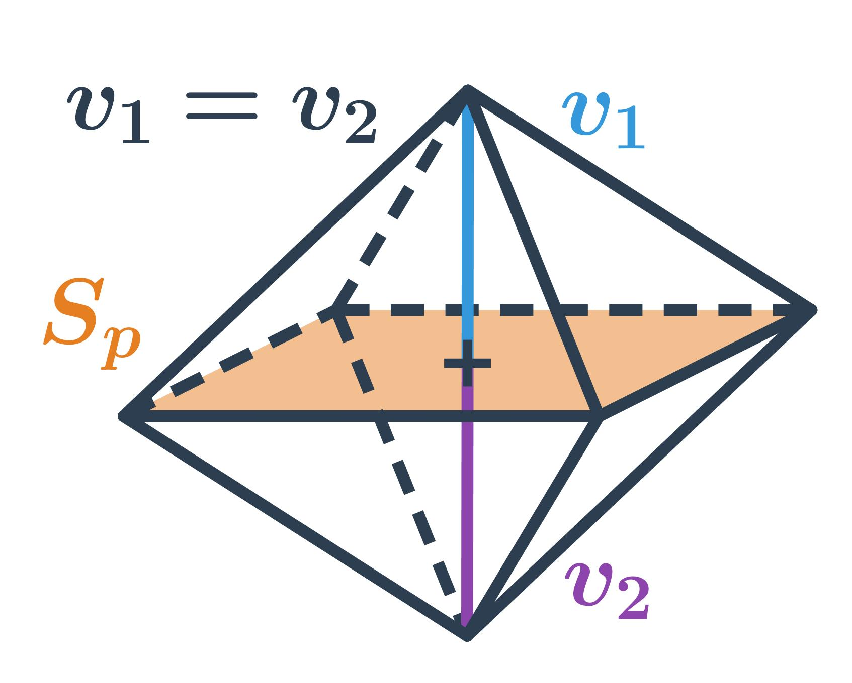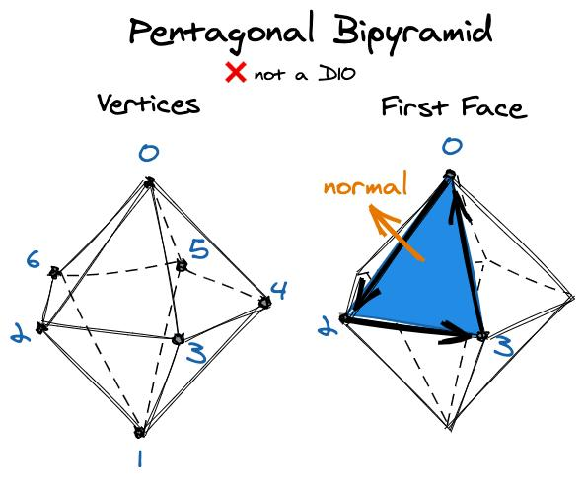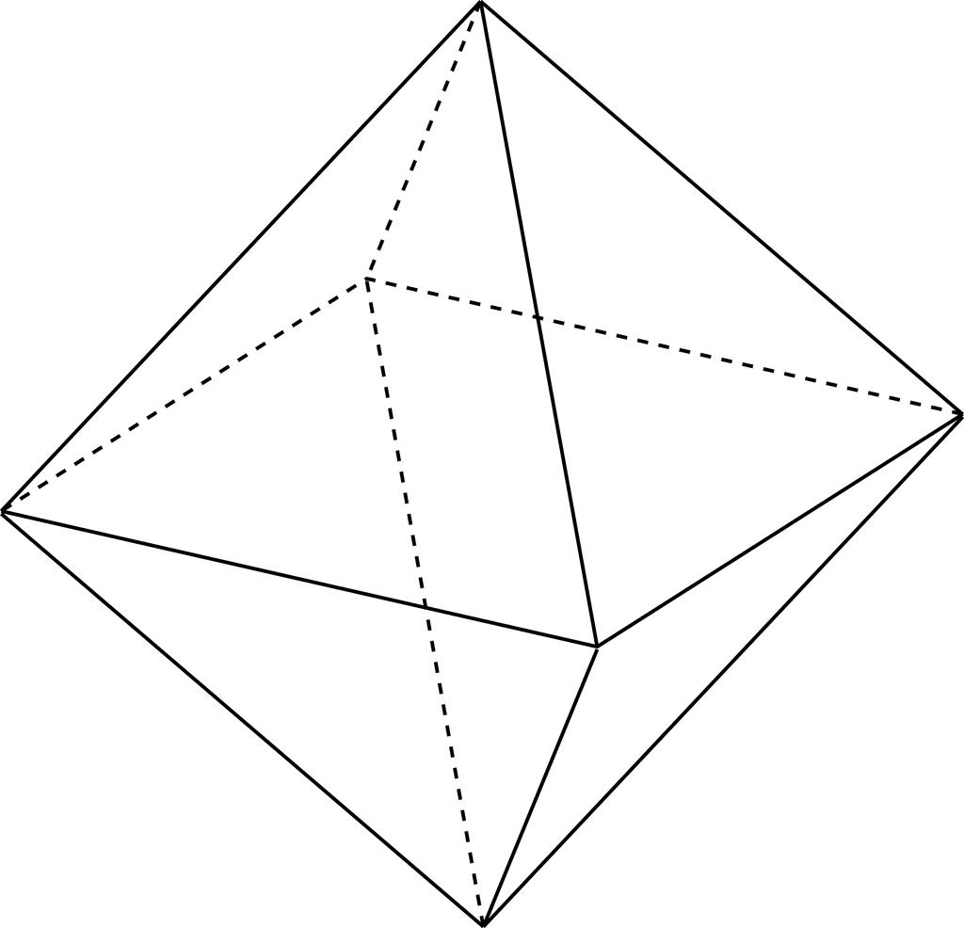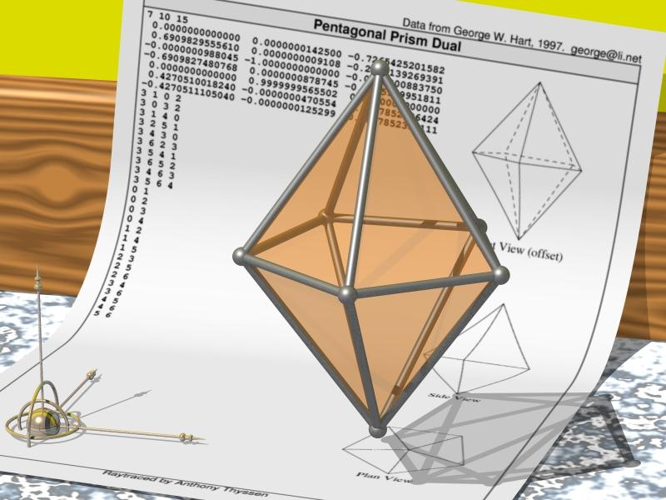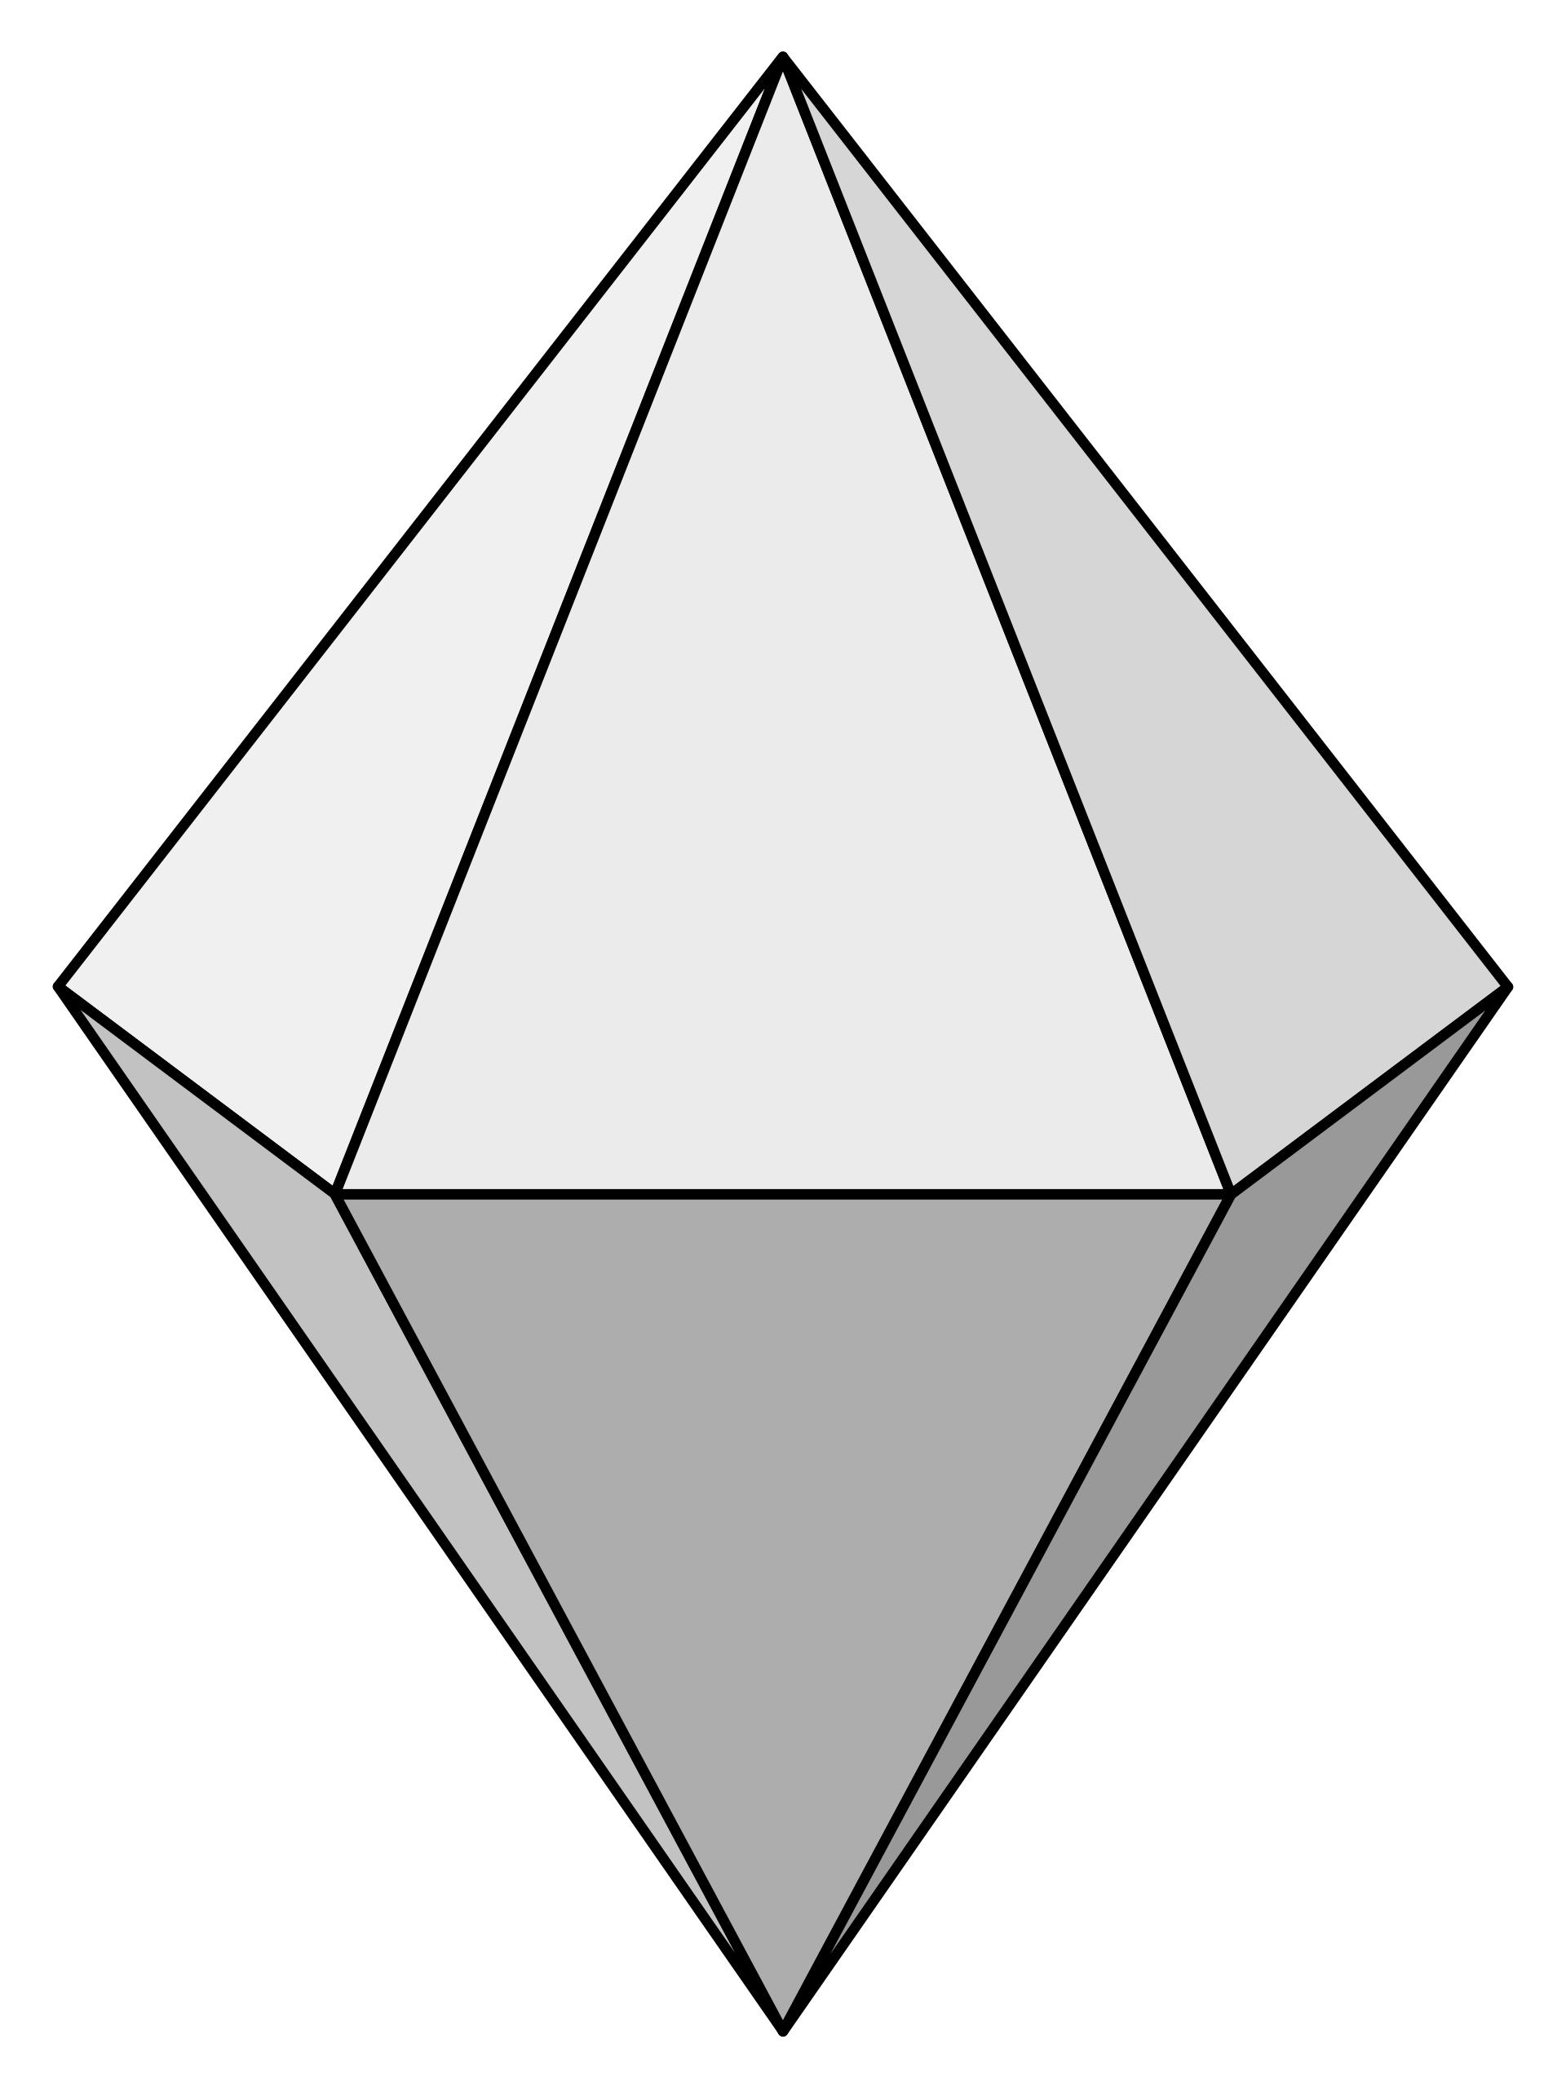

Constructing a Physical Model
# Source: AI Source: Provided by: [Data Path: Persons Table -> ID Column: 1, Name_En Column: Motasem Essam] -> From: [ChatGPT] on [7/25/2026]
- Draw a valid net containing the required triangular faces.
- Arrange the upper and lower triangular faces around the shared base-polygon arrangement.
- Add tabs along selected outer edges.
- Cut out the net carefully.
- Fold along the appropriate face boundaries.
- Join corresponding edges using adhesive.
- Check that the model forms a closed bipyramid.
Construction note: These procedures use geometric instruments and geometric relationships. They do not use coordinate-based construction.

Applications
# Source: AI Source: Provided by: [Data Path: Persons Table -> ID Column: 1, Name_En Column: Motasem Essam] -> From: [ChatGPT] on [7/25/2026]
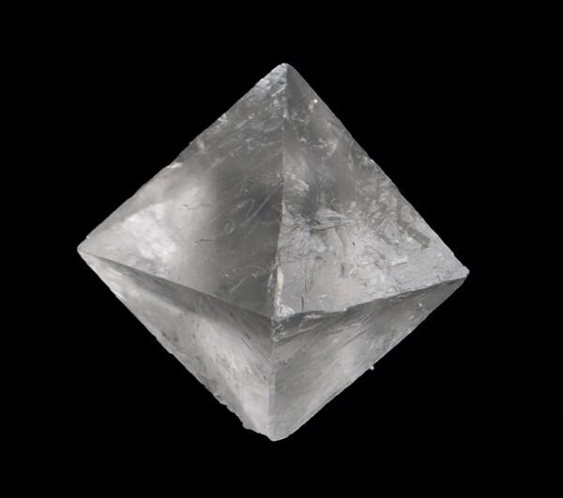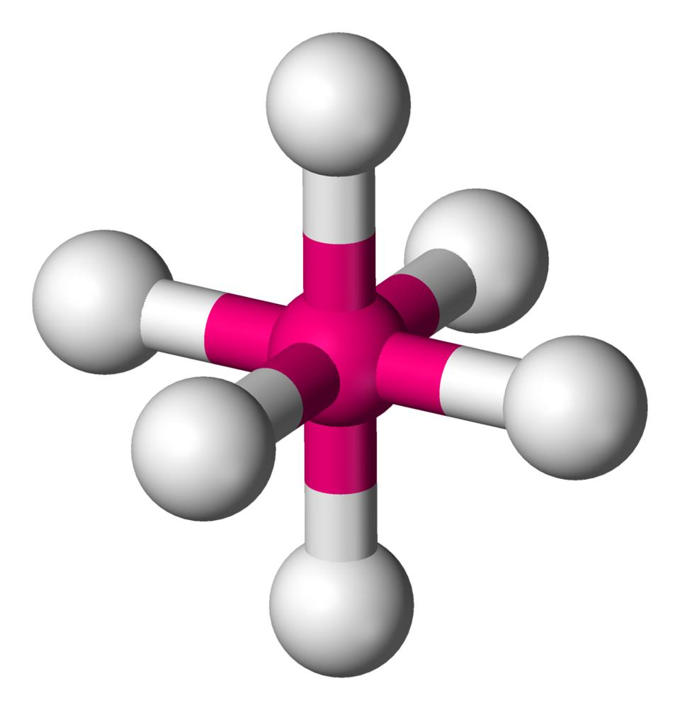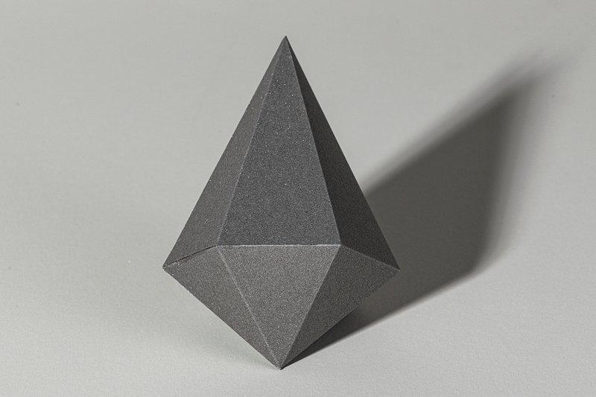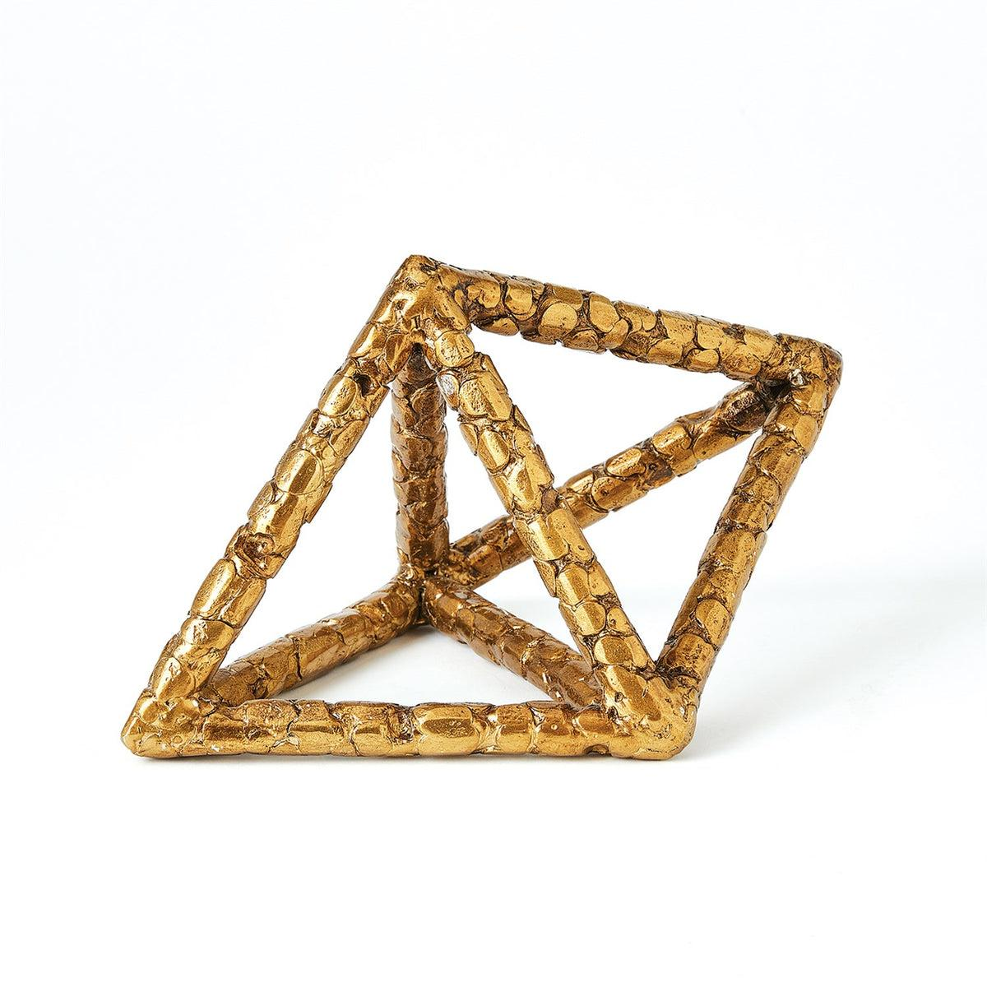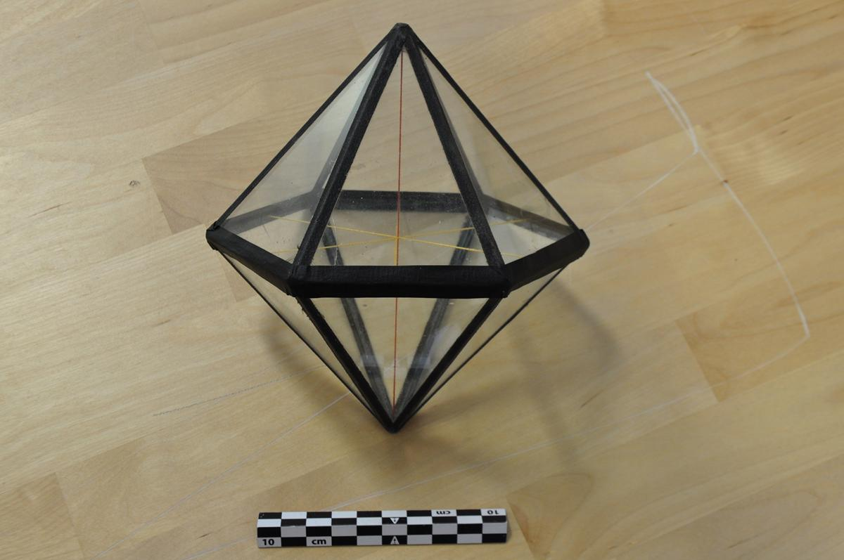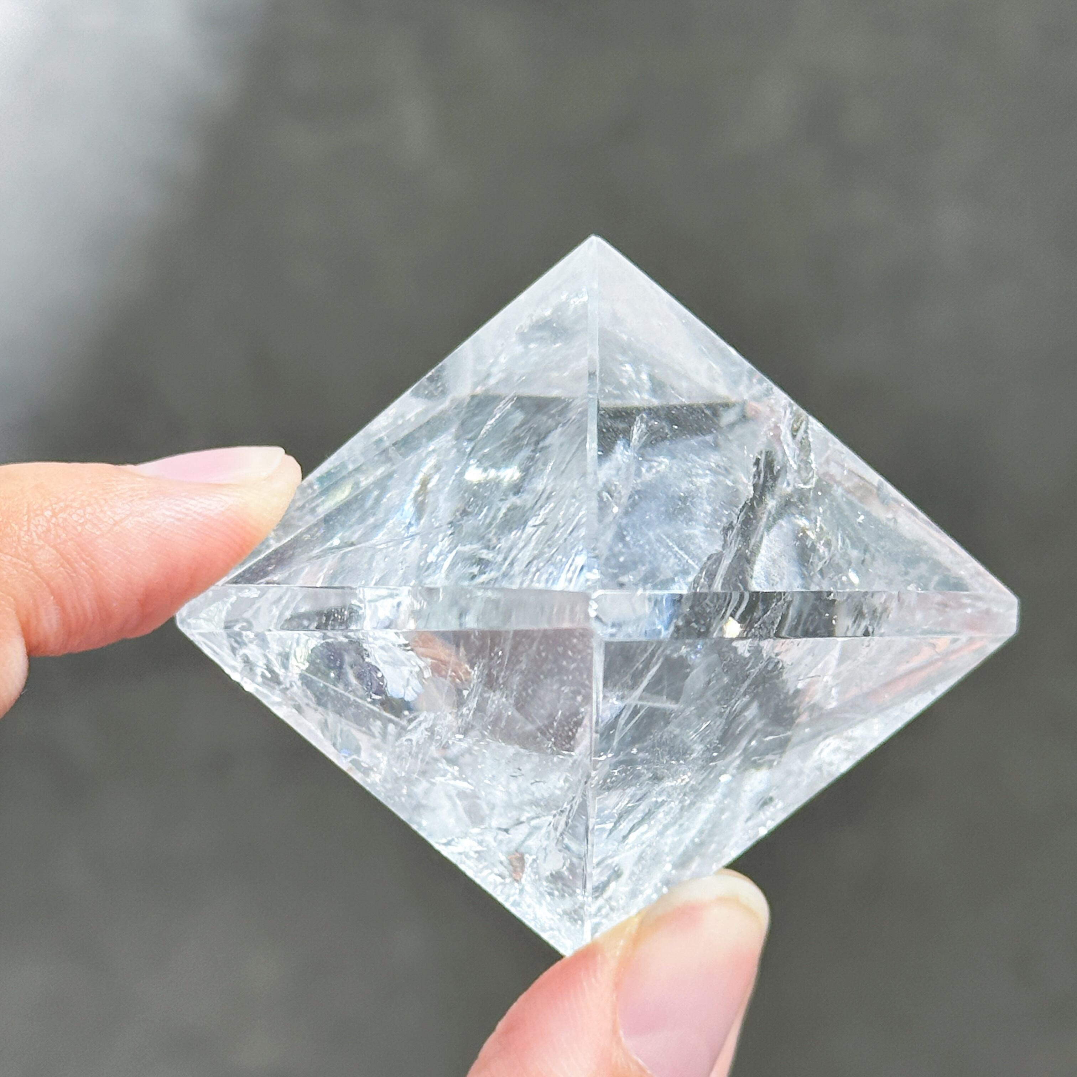
- Crystallography: Bipyramidal forms occur in mineral crystal structures.
- Molecular geometry: Bipyramidal arrangements describe the spatial arrangement of atoms, such as trigonal bipyramidal molecular geometry.
- Mathematics: Used in studying polyhedra, symmetry, and geometric constructions.
- Geometric modeling: Used in constructing three-dimensional objects and polyhedral models.

Key Points
# Source: AI Source: Provided by: [Data Path: Persons Table -> ID Column: 1, Name_En Column: Motasem Essam] -> From: [ChatGPT] on [7/25/2026]
- A bipyramid consists of two pyramids joined at a common polygonal base.
- It has two opposite apexes.
- Its external faces are all triangles.
- The common base is internal and is not counted as an external face.
- An $n$-gonal bipyramid has $2n$ faces, $3n$ edges, and $n+2$ vertices.
- A square bipyramid is a regular octahedron when its eight faces are equilateral triangles.
- A trapezohedron has kite-shaped faces, unlike a bipyramid.

Conclusion
# Source: AI Source: Provided by: [Data Path: Persons Table -> ID Column: 1, Name_En Column: Motasem Essam] -> From: [ChatGPT] on [7/25/2026]
A Bipyramid is a polyhedron formed by joining two pyramids along a common polygonal base. Its external surface consists entirely of triangular faces, and its classification depends on the number of sides of the common base.
Its general geometric structure is described by:
$$\boxed{F=2n, E=3n, V=n+2}$$
Classification note: The square bipyramid is the regular octahedron in its regular form. Bipyramids and trapezohedra are distinct polyhedral families, even though corresponding examples can share the same face, edge, and vertex counts.

